Classification & Taxonomy
What is classification?
- Organizing things into categories of some kind
- Grouped based on their characteristics

Why do Scientists Classify Living Things?
- Grouping living things helps us learn about them
- Grouping living things helps us understand them better

Who Figured Out How to Classify Living Things?
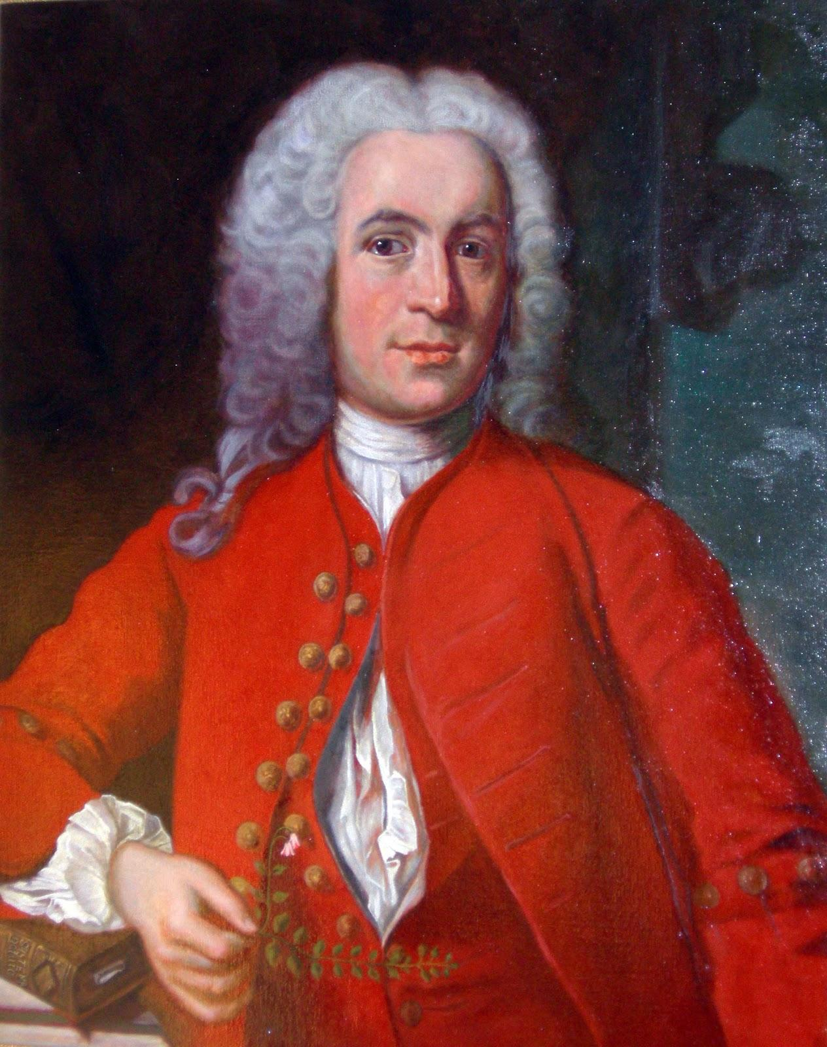
- Carolus Linnaeus developed the classification system used by scientists

What is the Classification System used by Scientists Today?
- Kingdom: Highest level...most general
  - 5 Kingdoms
    - Monera
      - Ex. bacteria (single, simple cells)
    - Protista
      - Ex. algae, amoeba (single, complex cells)
    - Fungi
      - Ex. mold, mushrooms and yeast
    - Plantae
      - Ex. producers who make their own food through photosynthesis
    - Animalia
      - Ex. mammals, reptiles, amphibians, birds and fish
  - Phylum or Phyla (Division for plants and fungi)
    - Grouped by shared characteristics
    - Share a common structure and organization
      - Ex. Chordate phylum are all animals with backbones
  - Class
    - Share common structures
      - Ex. Class Reptilia are all cold blooded
  - Order
    - Share common structures
      - Ex. Order Primates have flexible hands and feet
  - Family
    - Share common characteristics
      - Ex. Family Homindae walk on two feet
  - Genus
    - share common characteristics
      - Ex. Genus Homo (Latin for man) have large brains
  - Species
    - Most basic, members resemble each other
      - Ex. Species sapiens (Latin for wise) are known for their thinking abilities

How can you remember the levels of classification?
“Kids Prefer Cheese Over Fried Green Spinach”

What is Taxonomy?
- Scientific way of naming and classifying organisms
- Binomial Nomenclature
  - “two names” made of the organism’s genus and species
  - Ex. Humans are named Homo sapiens

How can we IDENTIFY organisms?
- There are millions of different species on Earth….how can we possibly identify them all?
- Ex. a beetle--even if we knew its kingdom (Animalia), its Phylum (Arthropoda) , its class ( insecta) and its order (coleoptera), you’d still have about 300,000 different species of beetles to choose from
- Scientists use a dichotomous key to identify organisms
  - asks a series of questions that can be answered in two ways (dichotomous)
  - Your answer leads you to another question with only two choices
  - The questions are asked about traits
  - Eventually, you are lead to the identity of the organism

